Superhero Profile Form
Male __ Female ___ Name:_____________________________

Describe your character’s superpower(s), special knowledge, or special ability:

What is your Hero/heroine’s goal or purpose? Be creative and specific:

What does your Hero/heroine look like? Include as many details as you can think of:

Where does he/ she come from?

Where does his/her superpower come from?

What helpful gadget(s) does your character use?

Does he or she drive a special vehicle? Describe it:

What kind of landscape does your character live in?

What kind of home or hideout does he or she live in?

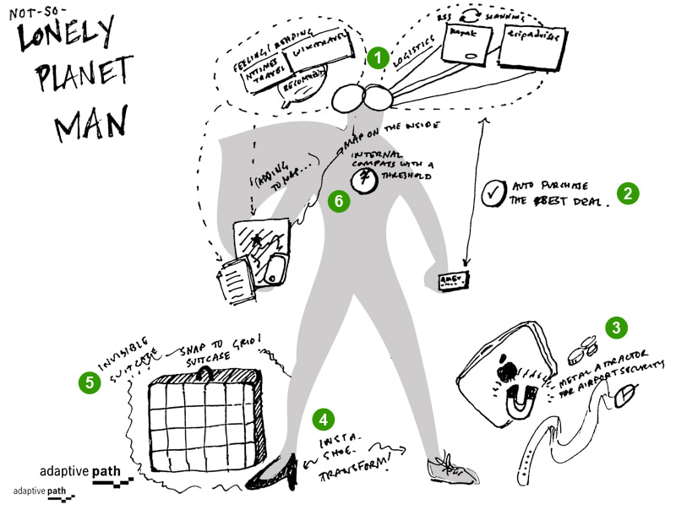
Does your character have any weaknesses?

Other important things to know about him/her:

